*Lab_Automation*

*E_Project*

*User guide*

|  |  |
| --- | --- |
| Enrollment ID | Name |
| Student 1414768 | Sarim Ur Rehman |
| Student 14147791 | Sadat Muhammad Khan |
| Student 1414766 | Muhammad Umama |
| Student 1417950 | Ebad Khan |

*Group members*

Faculty Sir Shahryar

Batch 2209b3

Semester 2



Introduction

Lab automation in electrical appliances involves integrating advanced technology and automated systems into electrical testing and research laboratories. This enhances precision, efficiency, and safety by reducing human intervention, ensuring accurate results, and streamlining various tasks, such as product testing, component characterization, and quality control. While initial setup costs and maintenance challenges exist, lab automation is a crucial trend that promises to revolutionize electrical engineering and product development in the field of electrical appliances.

Acknowledgements

We would like to express our sincere gratitude to everyone who has contributed to the successful completion of this project.

Our heartfelt thanks go to **Sir Shahryar** for providing invaluable guidance and support throughout the entire process.

We are deeply grateful to our colleagues and team members for their hard work, dedication, and collaboration. Their efforts have been instrumental in bringing this project to fruition.

We would also like to thank our families for their love and support, which has allowed us to stay focused and motivated.

Finally, we extend our thanks to all those who have provided us with the resources and opportunities necessary to complete this project.

This project would not have been possible without the help and support of all of you.

**Thank you**.

Problem Statement

Problem statement is attached separately in a file “**Lab Automation**”

**Standards plan:**

Every code block must have comments.

The logic of the program needs to be explained. Proper documentation should be maintained.

Complete Project Report along with synopsis, code and documentation should be prepared.

**Documentation:**

No project is complete without documentation. In fact, it is one of the most important activities during the development of a project. The documentation of an ideal project will be in the form of a project report comprising of the following documents:

* Certificate of Completion.
* Table of Contents.
* Problem Definition.
* Customer Requirement Specification.
* Project Plan.
* E-R Diagrams.
* Algorithms.
* GUI Standards Document.
* Interface Design Document.
* Task Sheet.
* Project Review and Monitoring Report.
* Unit Testing Check List.
* Final Check List.

Software Requirements

**Hardware**

* A minimum computer system that will help you access all the tools in the courses is a Pentium 166 or better
* 128 Megabytes of RAM or better

**Operating System**

* LINUX / Windows 2000 Server (or higher if possible)

**Software**

* PHP
* MySQL
* PERL
* Apache

Log in

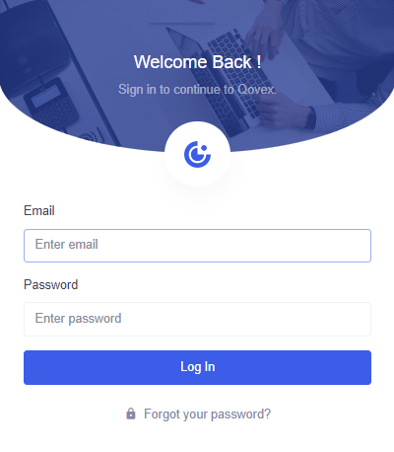

Add Products

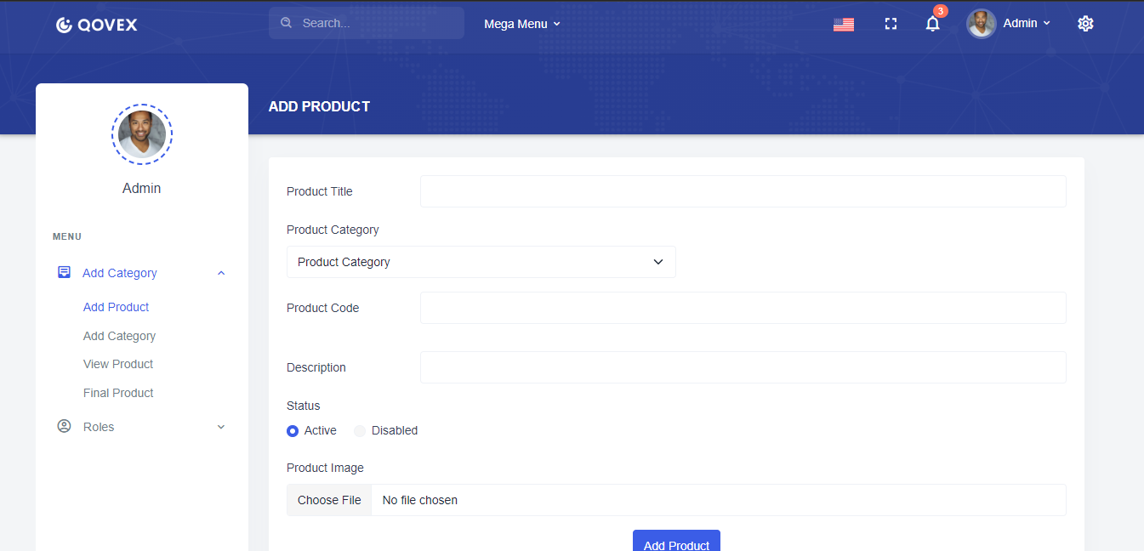

Add Products



View Products

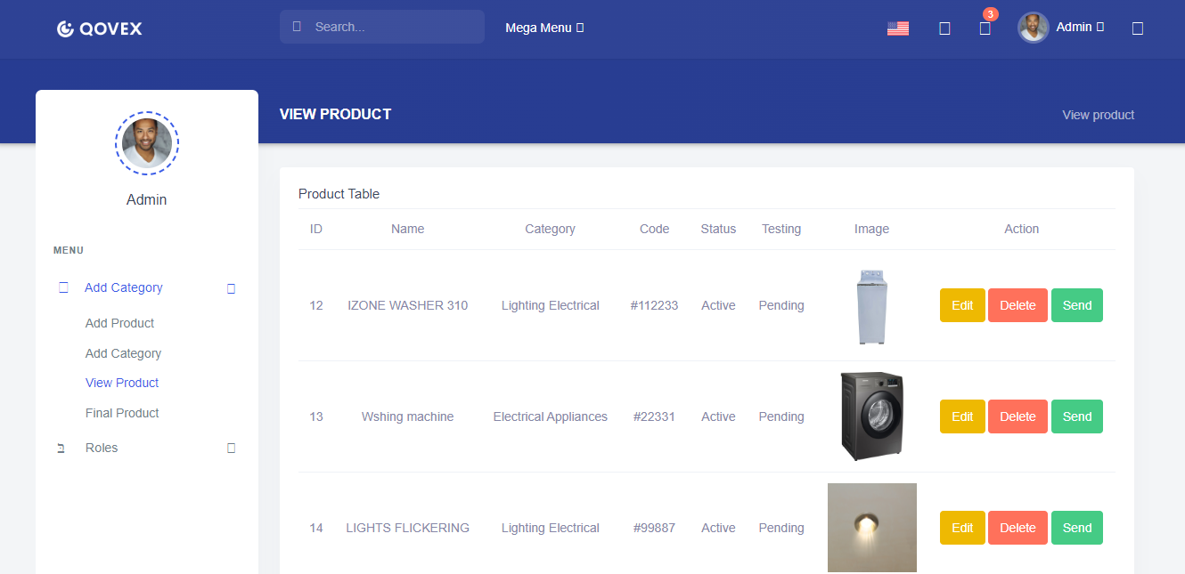

Thank You